**BEEF TENDERLOIN WITH SPICY CAJUN SHRIMP SAUCE WITH VICTORIA TAYLOR’S NEW ORLEANS**

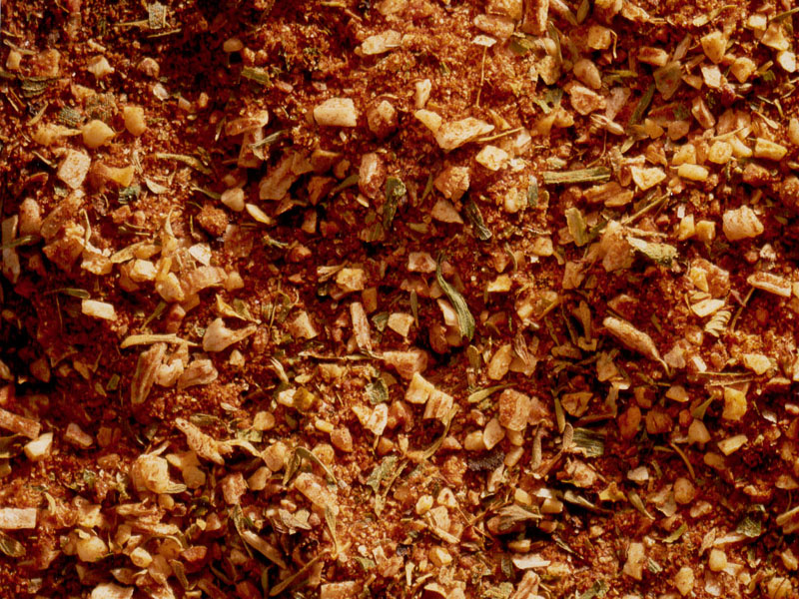

**Difficulty Level:**

Medium

**Prep Time:**

50 minutes

**Cook Time:**

8-10 minutes

**Total Time:**

1 hour

**Serving size:**

4

2 tablespoons plus ½ teaspoon divided [New Orleans](http://www.vgourmet.com/new-orleans)

1/3 pound small raw shrimp, shell-on (31-40/pound)

1 cup water

¼ teaspoon salt

4 tenderloin steaks or rib eye steaks (4-6 ounces each)

½ cup finely diced red bell pepper (about ½ pepper)

½ cup chopped fresh tomato

1 cup sliced fresh button mushrooms

2 tablespoons sherry

½ teaspoon Worcestershire sauce

1 tablespoon fresh lemon juice

2 tablespoons peanut oil

2 tablespoons milk

scallions for garnish

[Share on facebookShare on twitter](http://www.vgourmet.com/beef-tenderloin-spicy-cajun-shrimp-sauce-victoria-taylor%E2%80%99s-new-orleans)[Share on google_plusone_share](http://www.addthis.com/bookmark.php?v=300&winname=addthis&pub=ra-5250a86b44a96ffc&source=tbx32-300&lng=en-US&s=google_plusone_share&url=http%3A%2F%2Fwww.vgourmet.com%2Fbeef-tenderloin-spicy-cajun-shrimp-sauce-victoria-taylor%25E2%2580%2599s-new-orleans&title=Beef%20Tenderloin%20with%20Spicy%20Cajun%20Shrimp%20Sauce%20with%20Victoria%20Taylor%E2%80%99s%20New%20Orleans%20%7C%20Victoria%20Gourmet&ate=AT-ra-5250a86b44a96ffc/-/-/52f3f6221bf61727/2&frommenu=1&uid=52f3f622b1d552f6&ct=1&pre=http%3A%2F%2Fwww.vgourmet.com%2Fby_ingredients%2F399&tt=0&captcha_provider=nucaptcha)[Share on pinterest_share](http://www.vgourmet.com/beef-tenderloin-spicy-cajun-shrimp-sauce-victoria-taylor%E2%80%99s-new-orleans)[Share on print](http://www.vgourmet.com/beef-tenderloin-spicy-cajun-shrimp-sauce-victoria-taylor%E2%80%99s-new-orleans)[Share on email](http://www.vgourmet.com/beef-tenderloin-spicy-cajun-shrimp-sauce-victoria-taylor%E2%80%99s-new-orleans)

**Directions:**

1. Peel shrimp and set shrimp aside reserving shells.

2. Place shells, water, salt, and ½ teaspoon New Orleans into a small stock pot. Bring to a boil, skim foam off of the top, and simmer over low heat, uncovered until reduced by ¼ (20 – 25 minutes). Set aside.

3. Devein shrimp and slice lengthwise.

4. Coat steaks with up to 2 tablespoons New Orleans. The more you use, the more heat you will have.

5. Heat oil in cast iron or other heavy nonstick skillet. When hot, add steaks.

6. Cook for 8 –10 minutes and flip. Cook for about 4 –5 minutes on the second side until the internal temperature equals 120-125 degrees (medium-rare).

7. Place cooked steaks on plate and cover loosely with aluminum foil and set aside.

8. In the same pan add bell pepper, tomato, and mushrooms and cook for 3 minutes.

9. Add shrimp and cook for 2 minutes, turning shrimp to cook on all sides.

10. Add sherry, shrimp stock, lemon juice, and Worcestershire sauce and cook for 3 minutes.

11. Add milk to mixture and any meat juices that have collected on the plate. Cook for 2 – 3 minutes until slightly thickened.

12. Serve steaks warm and top with ¼ of the shrimp with sauce on each.